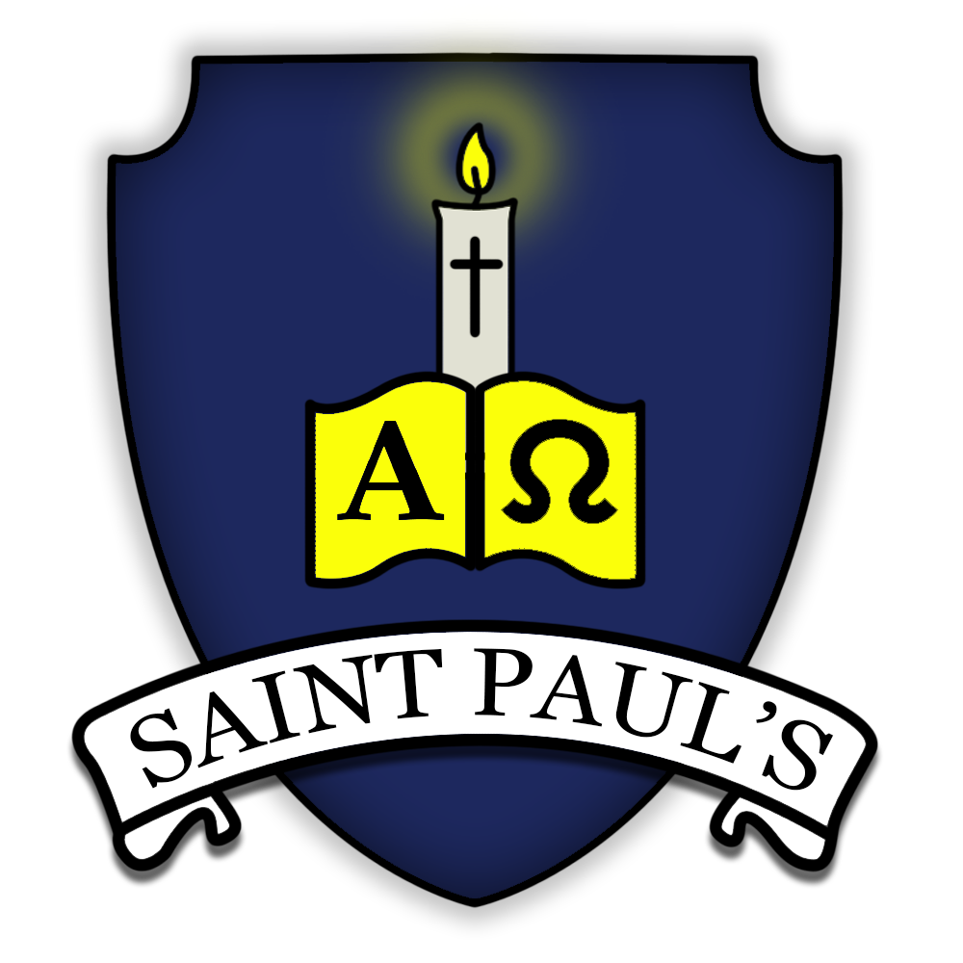
St Paul’s Catholic Primary School Subject: Geography Leader: Joshua Caves
Long term plan is below followed by the structure of each unit and then the knowledge organiser. Each unit has an assessment. Teachers should give it to the pupils cold at the beginning of the unit and then again at the end of the unit. The assessment will show what the pupils have learnt and what teachers need to recover in their next unit.
Our Vision:

At St Paul’s, we seek to provide pupils with the essential knowledge they need to be educated citizens in tomorrow’s world. It reflects our vision that every child will be supported to achieve their full potential, growing into the person God wants them to be and flourishing in His love.

Our curriculum is rooted in a rich knowledge and understanding of our history and heritage, our culture and community and our local challenges and opportunities. Our intent is to make a real difference to children’s lives, raising their own and others’ aspirations, securing educational success and deepening their knowledge and love of self and others around them.

We seek to develop our children’s awe and wonder, their self confidence and their ability to be an ‘agent of change’. We want our children to know their world, to keep themselves safe and healthy, to live economically, to ‘set the world on fire’.

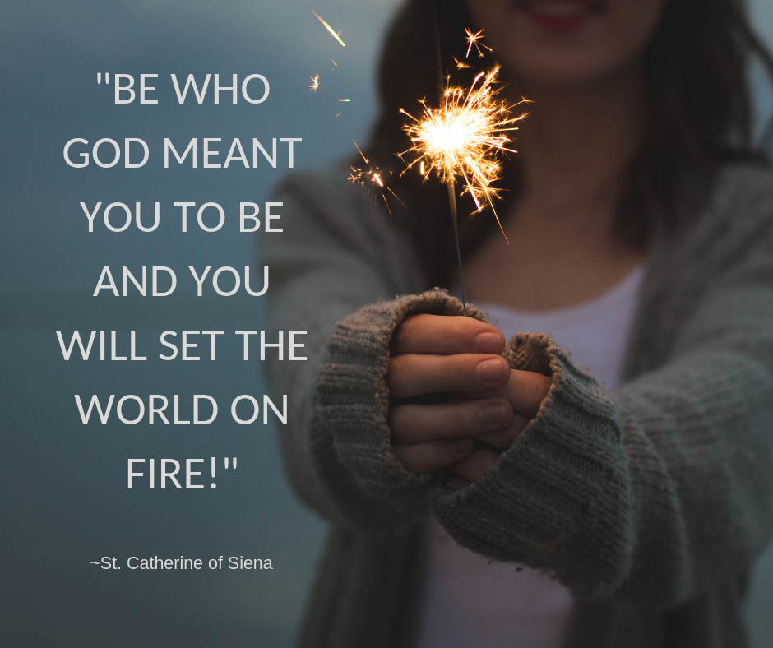

The intent of our Geography Curriculum at St Paul’s

Our high-quality Geography education at St Paul’s aims to inspire pupils’ curiosity to know more about the world and its people. Pupils will develop the fundamental Geography skills that are need for them to be educated citizens in tomorrow’s world. It reflects our vision that every child will be supported to achieve their full potential and receive the essential knowledge that will remain with them for rest of their life.

The aims for implementation of our curriculum for Geography at St Paul’s

To ensure that all pupils:
- Develop contextual knowledge of the location of globally significant places, including their defining physical and human characteristics and how these
change over time.
- Pupils are competent Geographical explorers, using “fieldwork” and “enquiry” to find out about places in an increasingly independent way, using
- Pupils will develop a progressive range and development of mapping skills and vocabulary to: collect, analyse and communicate with a range of data gathered through experiences of fieldwork that deepen their understanding of geographical processes.
- interpret a range of sources of geographical information, including maps, diagrams, globes, aerial photographs and Geographical Information Systems
(GIS)
- Pupils will be able to communicate geographical information in a variety of ways, including through maps, numerical and quantitative skills and writing at length

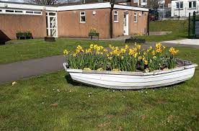
Reception EYFS:

During the Early Years Foundation Stage, children will develop their geographical understanding through child-initiated and adult-initiated activities in their continuous provision. At St Paul’s we place a large emphasis on developing children’s vocabulary through high-quality and rich texts and first-hand experiences. Regular opportunities for outdoor learning provide opportunities to develop children’s understanding of the changing seasons and different weather conditions. Reception children have a regular ‘welly Wednesday’ where they explore the local environment of our own school and grounds. During the autumn term children will begin their geographical learning journey by exploring the geography of our own school and grounds, before progressing onto exploring the local area during the Spring term. Once children have a secure geographical understanding of the area in which they live, they will begin to explore contrasting environments from around the world during the Summer term.

Early Years Foundation Stage Framework (2021)

Educational Programmes: Understanding the World

Understanding the world involves guiding children to make sense of their physical world and their community. The frequency and range of children’s personal
experiences increases their knowledge and sense of the world around them – from visiting parks, libraries and museums to meeting important members of
society such as police officers, nurses and firefighters. In addition, listening to a broad selection of stories, non-fiction, rhymes and poems will foster their
understanding of our culturally, socially, technologically and ecologically diverse world. As well as building important knowledge, this extends their familiarity
with words that support understanding across domains. Enriching and widening children’s vocabulary will support later reading comprehension.

ELG: People, Culture and Communities

Children at the expected level of development will: - Describe their immediate environment using knowledge from observation, discussion, stories, non-fiction
texts and maps; - Know some similarities and differences between different religious and cultural communities in this country, drawing on their experiences
and what has been read in class; - Explain some similarities and differences between life in this country and life in other countries, drawing on knowledge
from stories, non-fiction texts and – when appropriate – maps.

ELG: The Natural World
Children at the expected level of development will: - Explore the natural world around them, making observations and drawing pictures of animals and
plants; - Know some similarities and differences between the natural world around them and contrasting environments, drawing on their experiences and
what has been read in class; - Understand some important processes and changes in the natural world around them, including the seasons and changing
states of matter

Year group/Term | Autumn term | Spring term | Summer term
Reception | Exploring maps | Outdoor adventures | Around the world
Year 1 | What is it like here? | What is the weather like in the UK? | What can you see at the coast?
Year 2 | Where am I? | Would you prefer to live in a hot or cold place? | What is it like to live in Shanghai?
Year 3/4 | Why do people live near volcanoes? | Why are rainforests important to us? | Where does our food come from?
Year 4/5 | Who lives in Antarctica? | Are all settlements the same? | What are rivers and how are they used?
Year 6 | What is life like in the Alps? | Would you like to live in the desert? | Where does our energy come from?

Reception
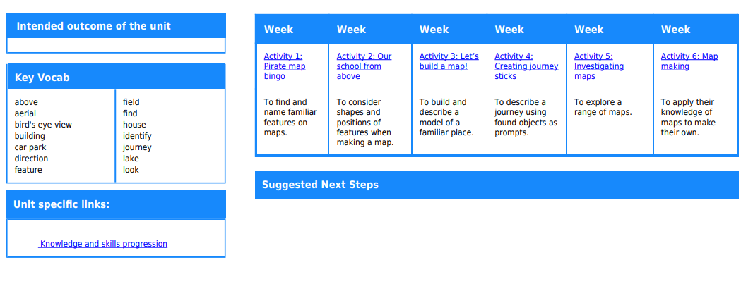

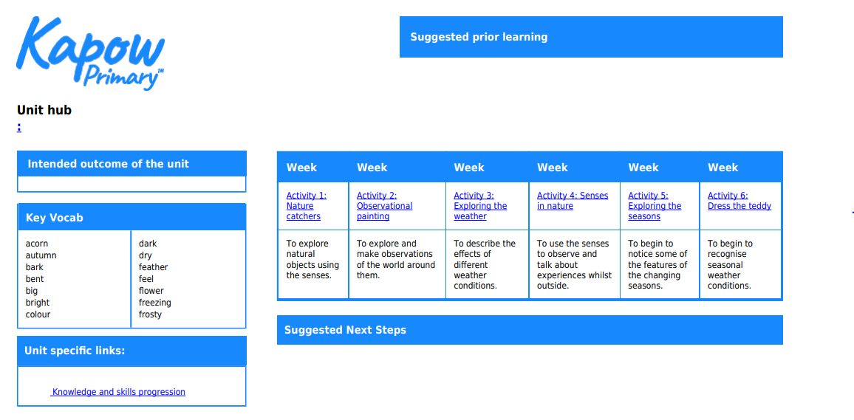

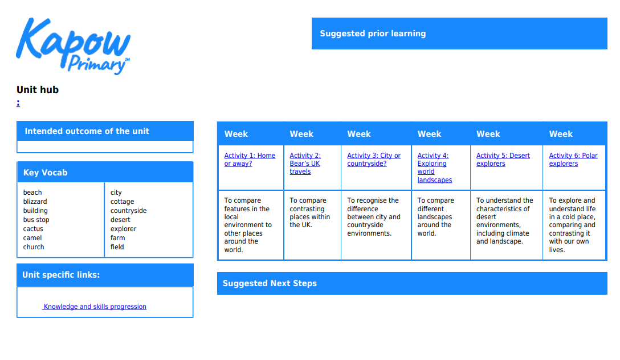

Year 1

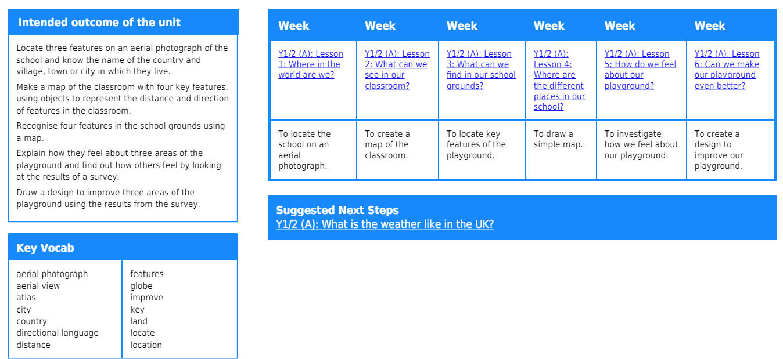

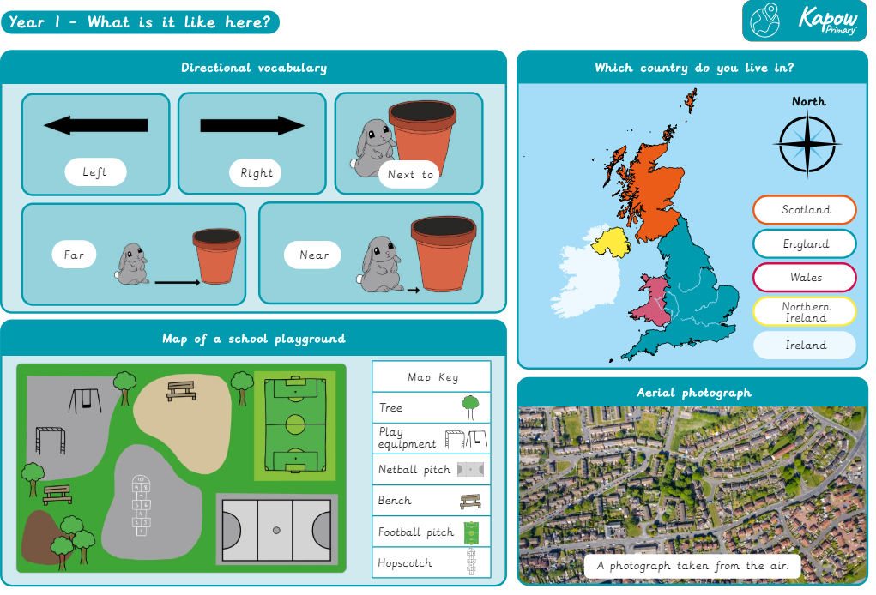
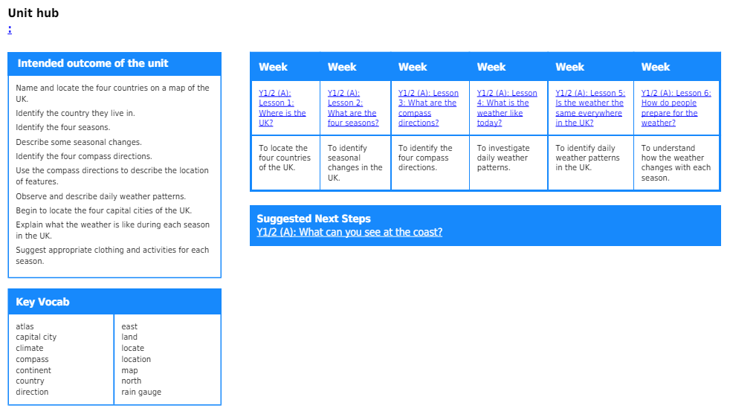

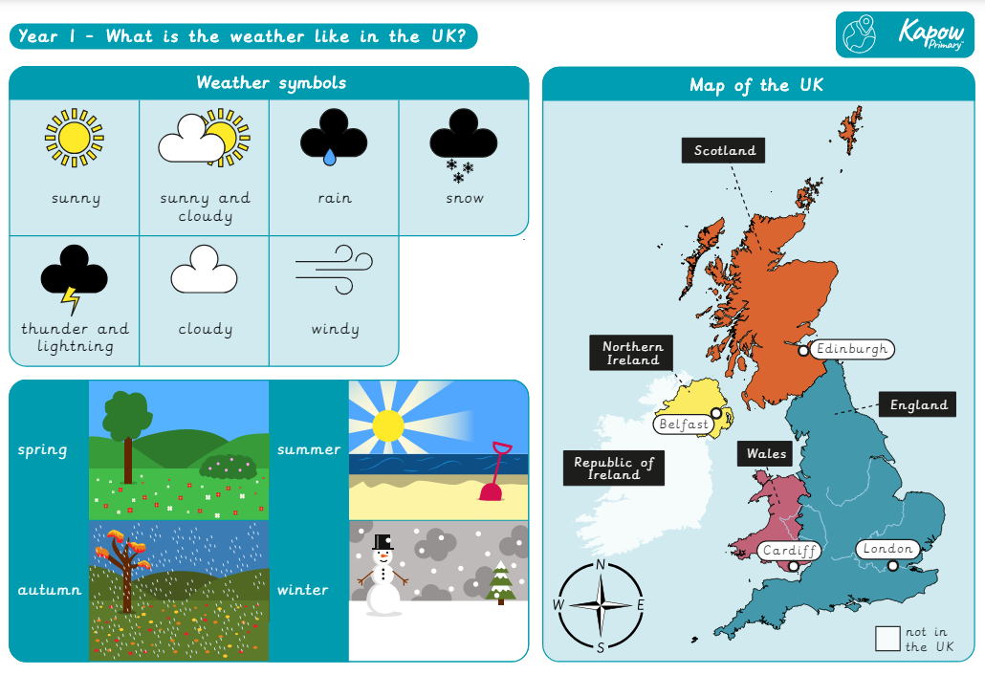
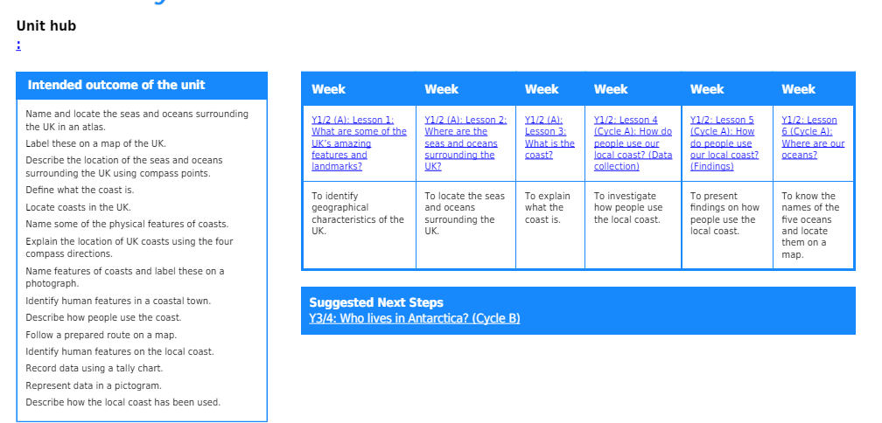

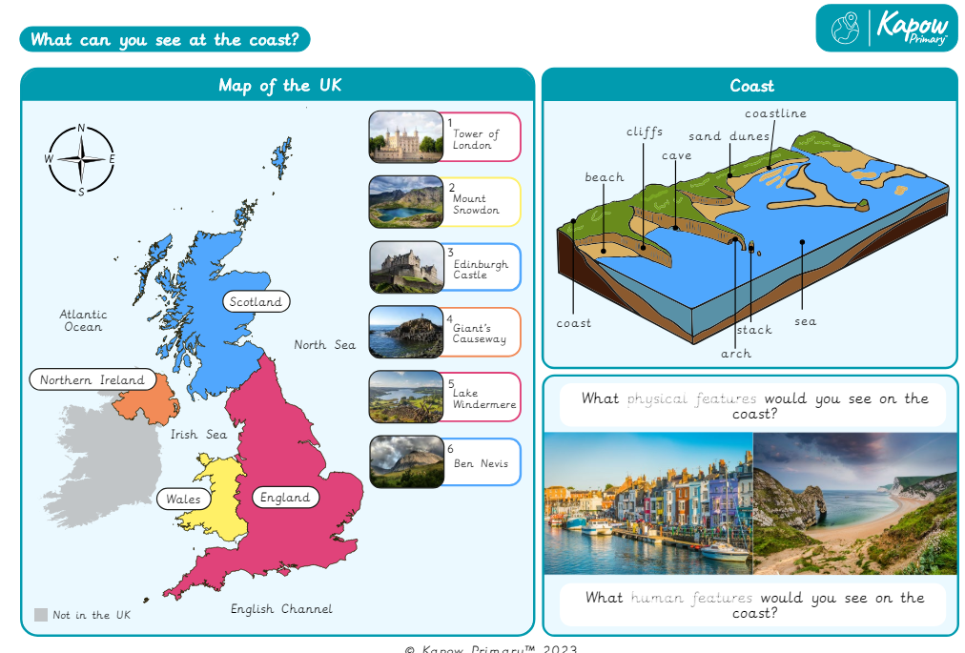

Year 2
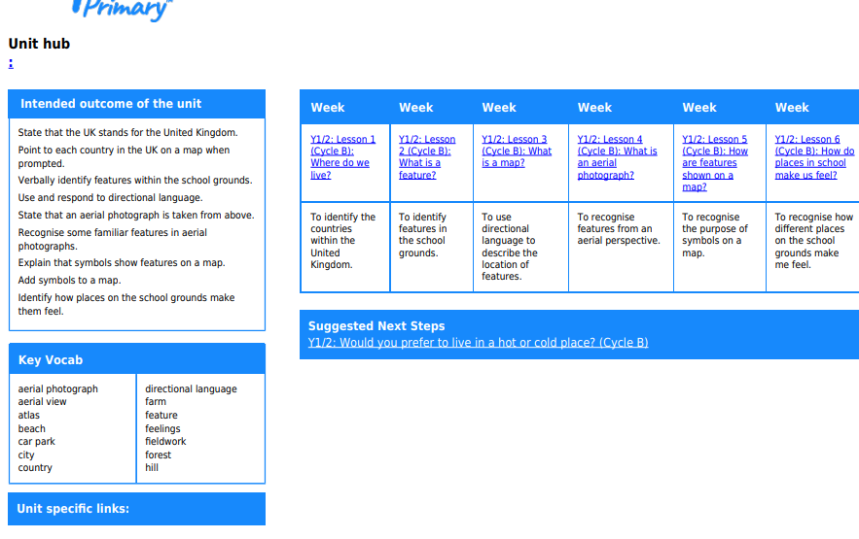

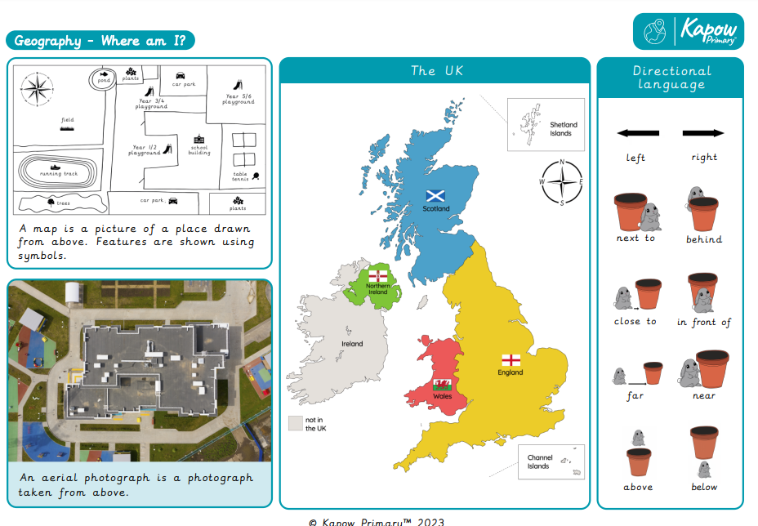

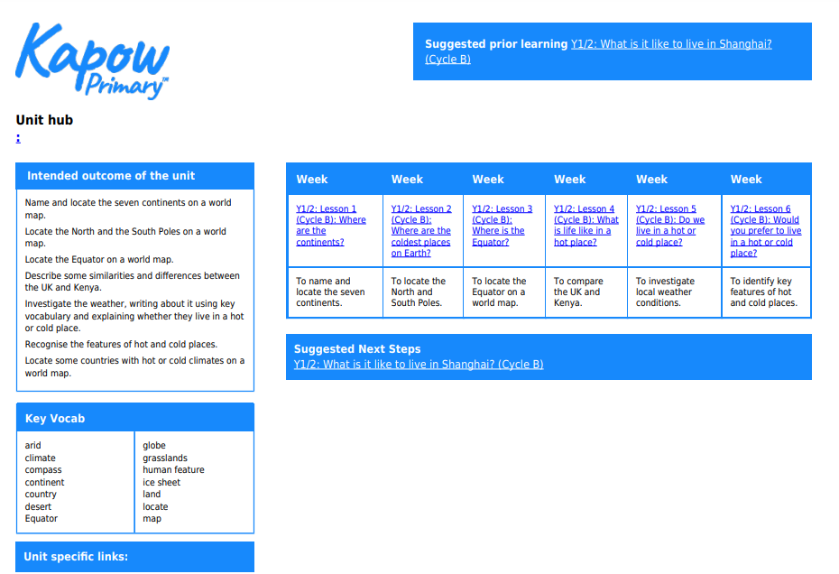
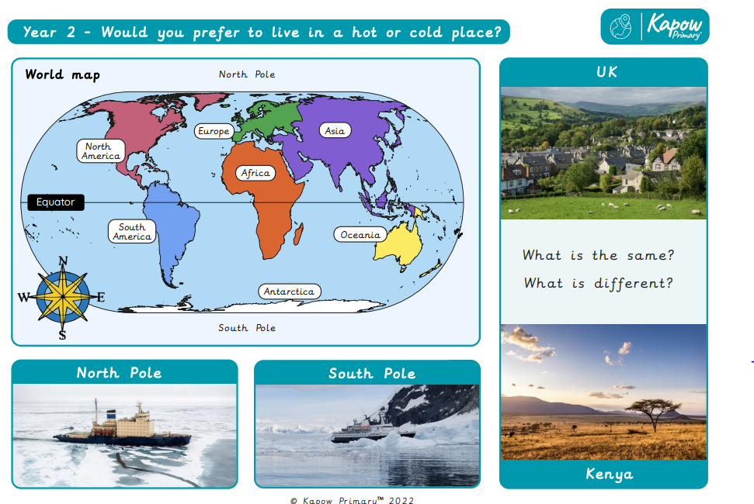
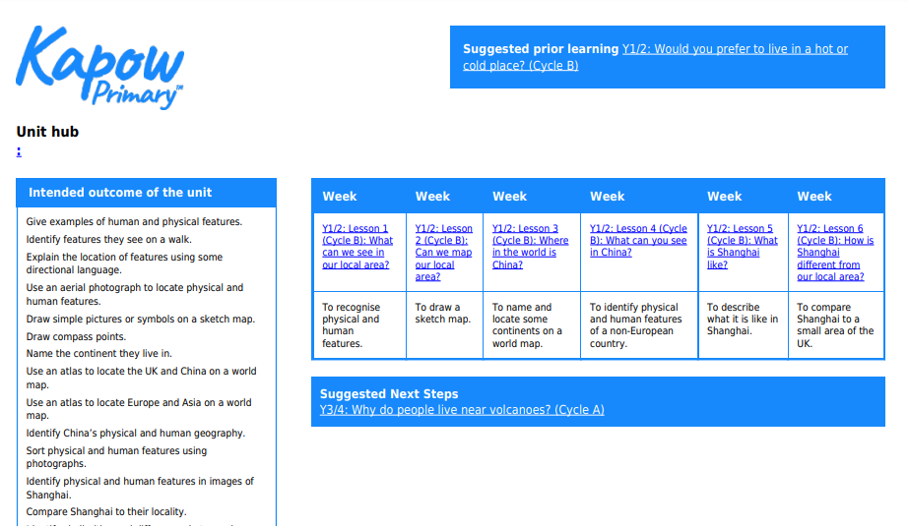

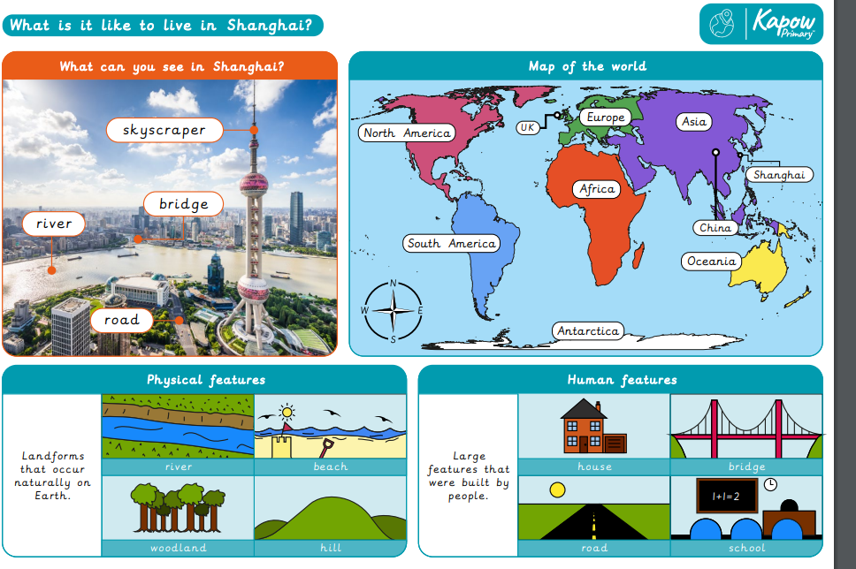

Year 3/4
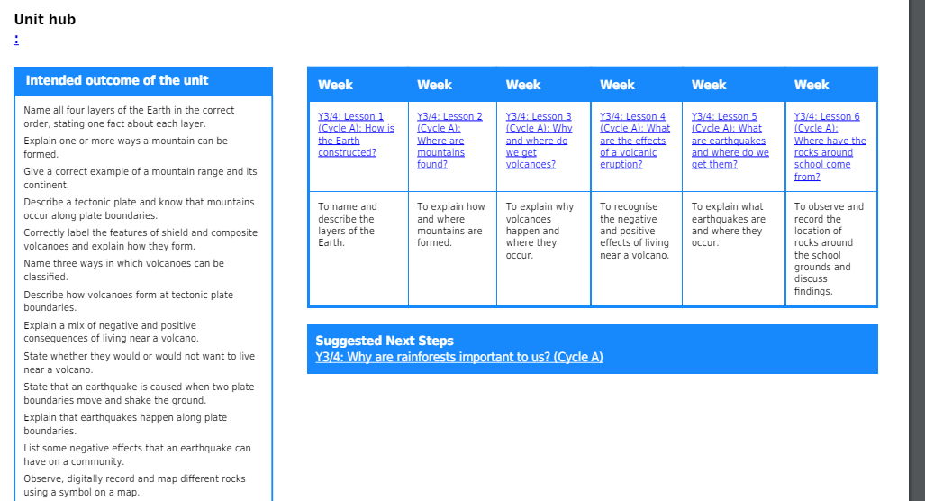

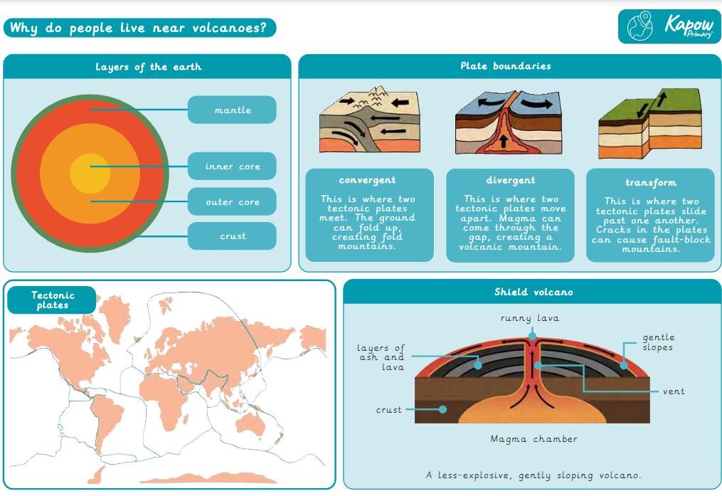

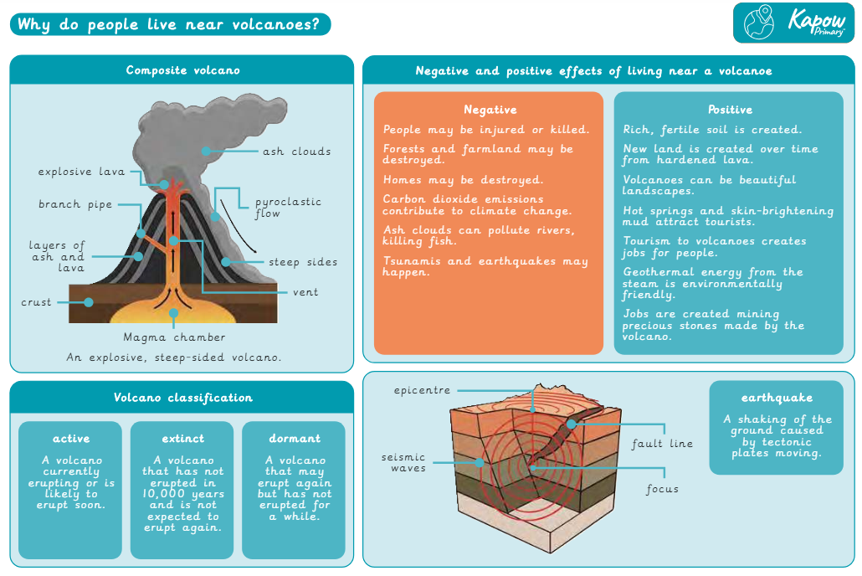
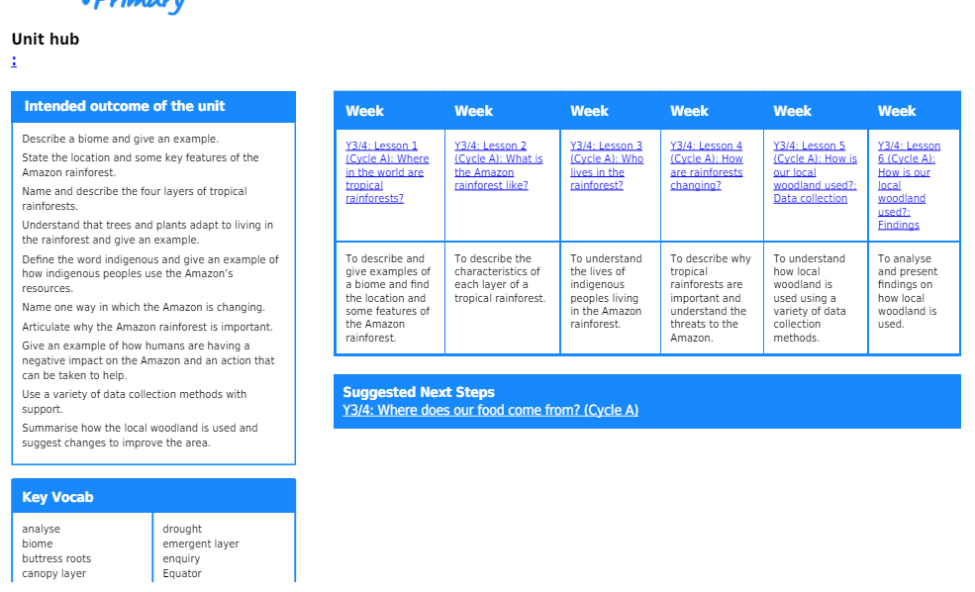

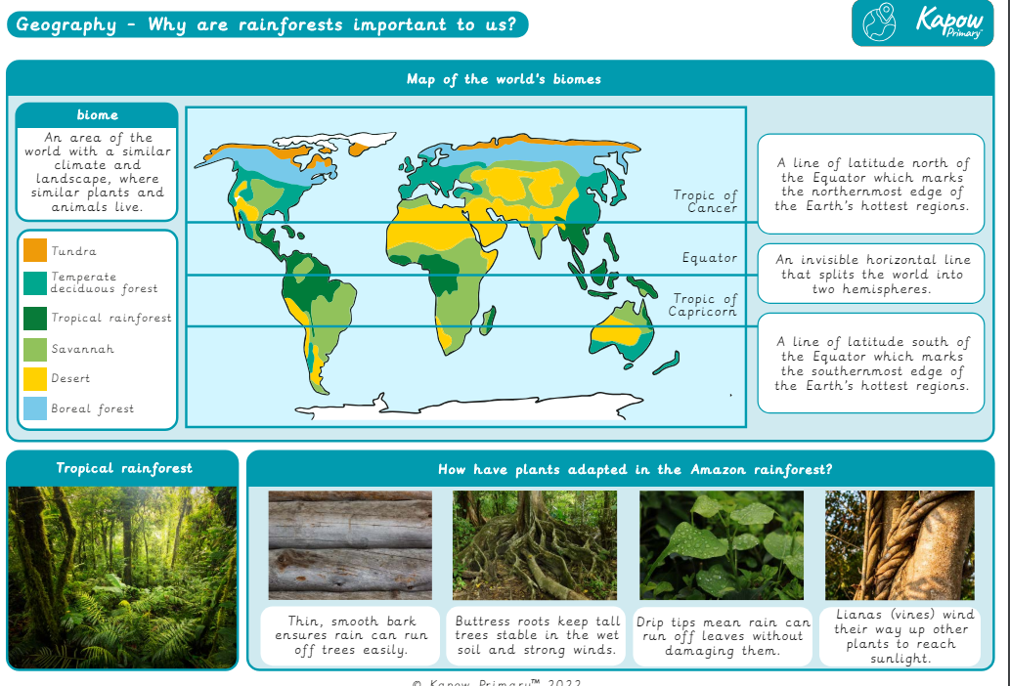

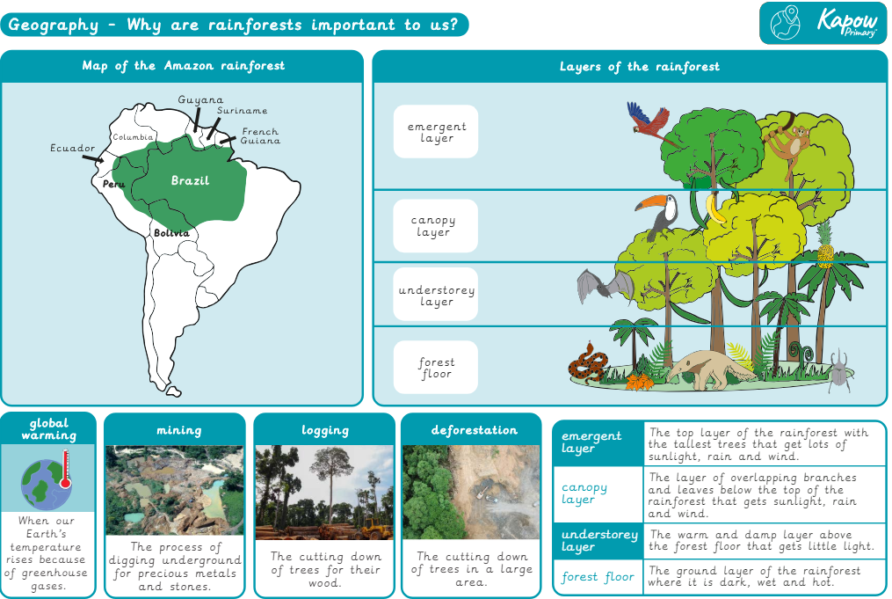

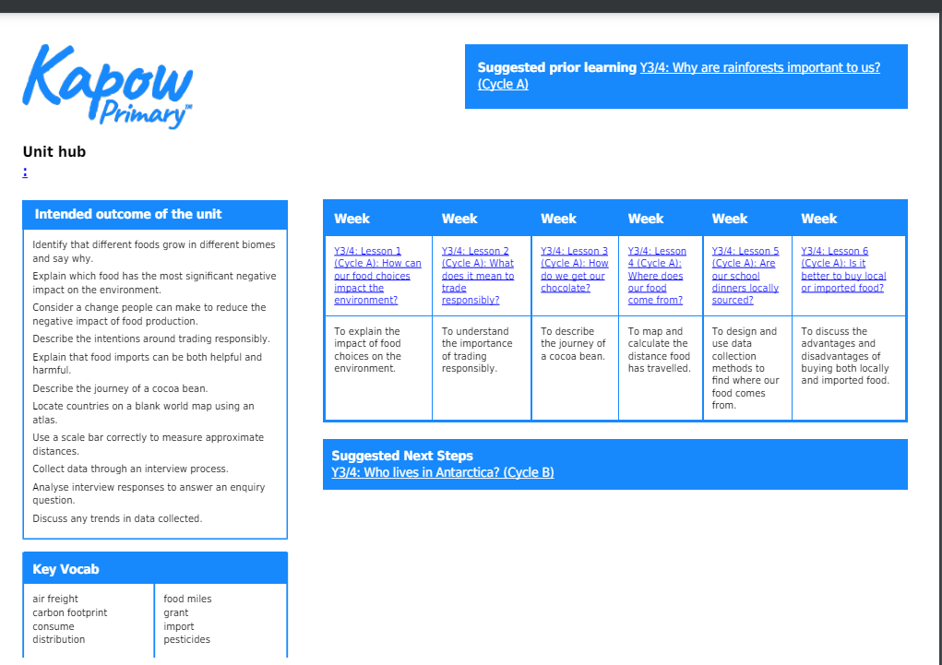
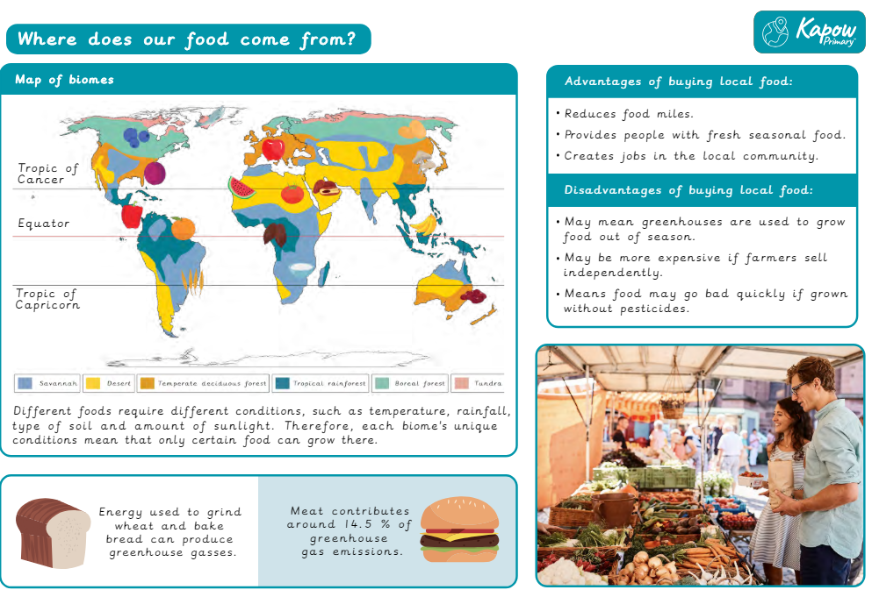

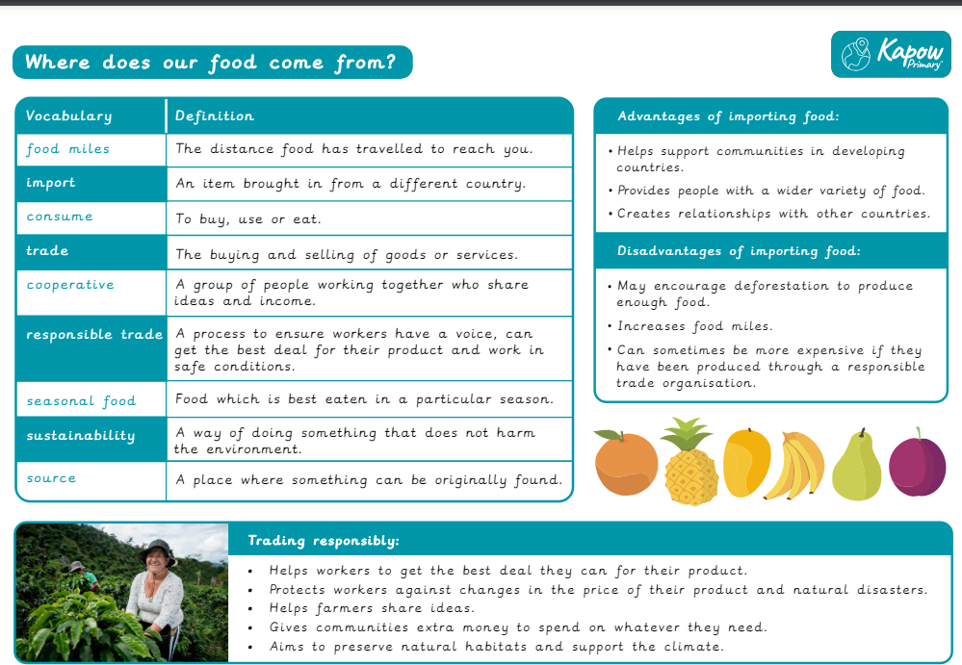
Year 4/5
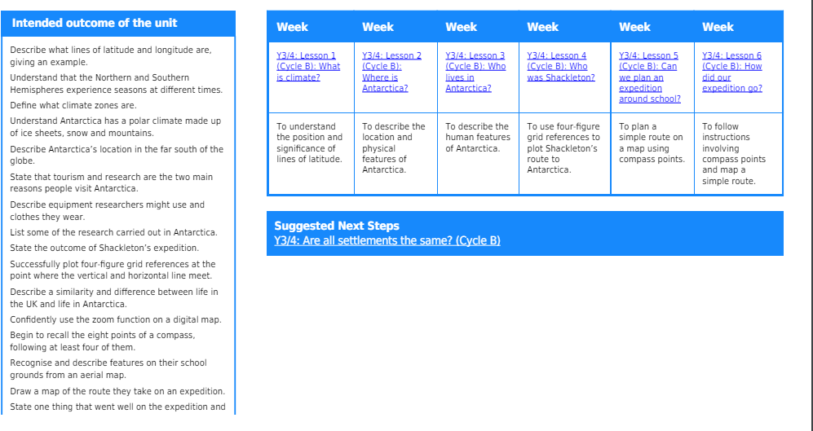

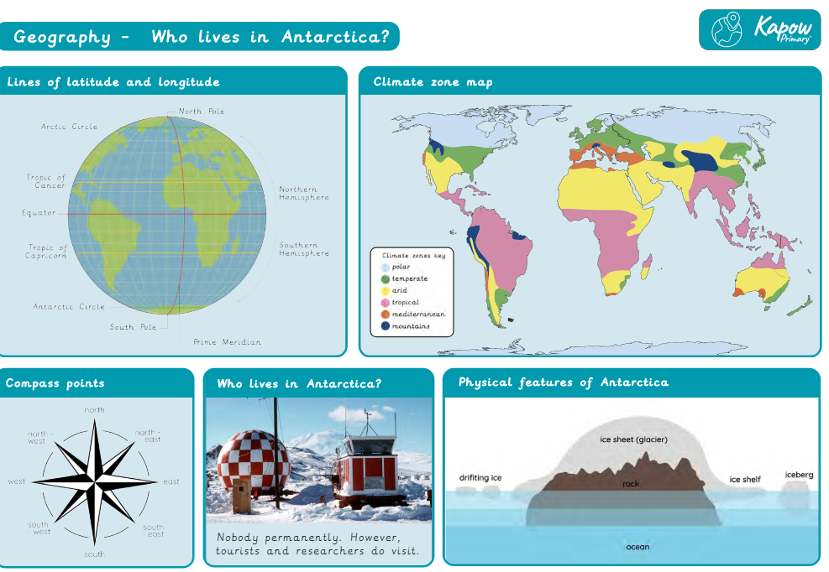

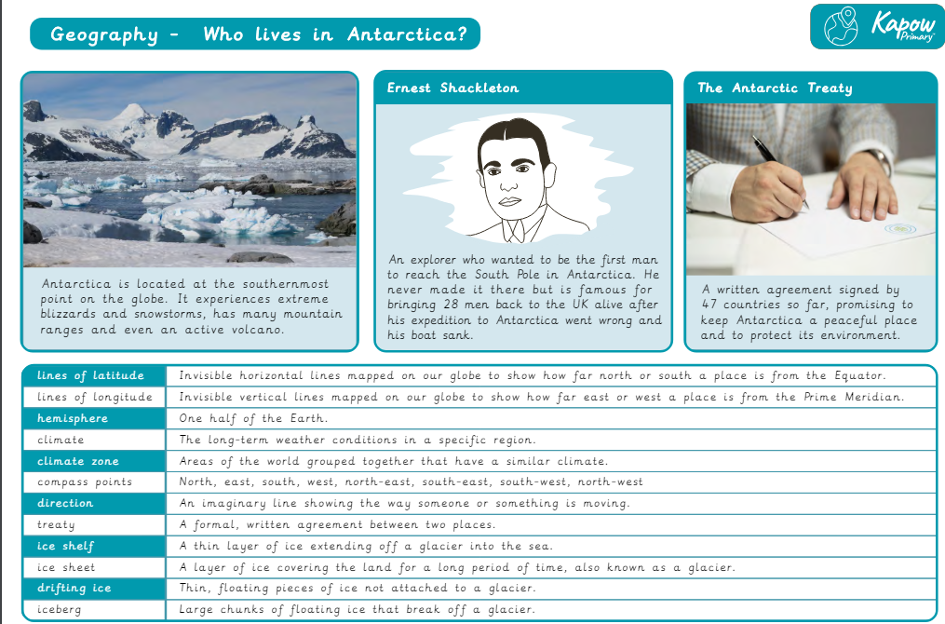
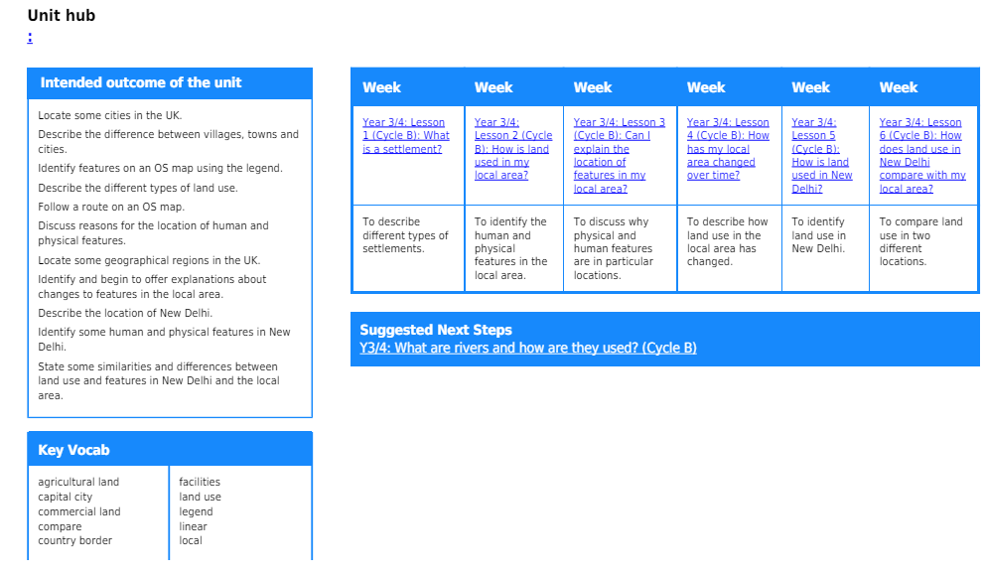

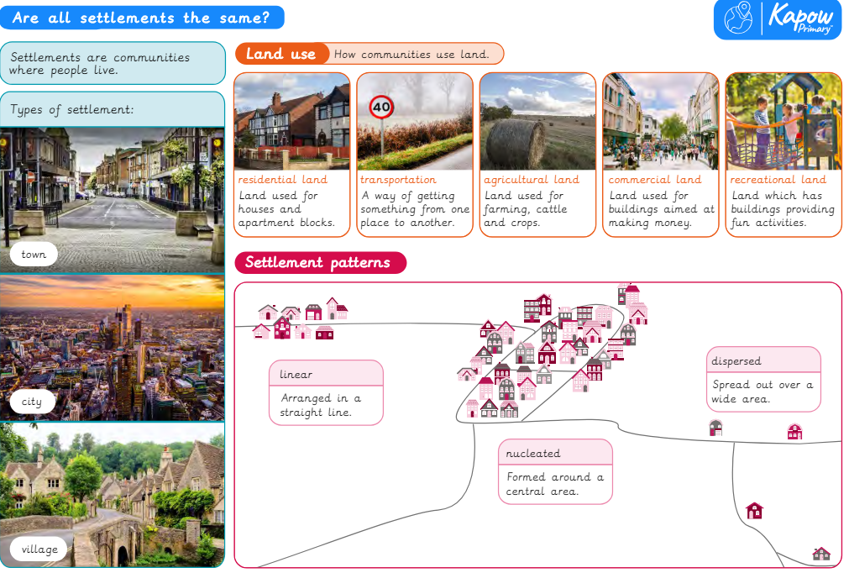
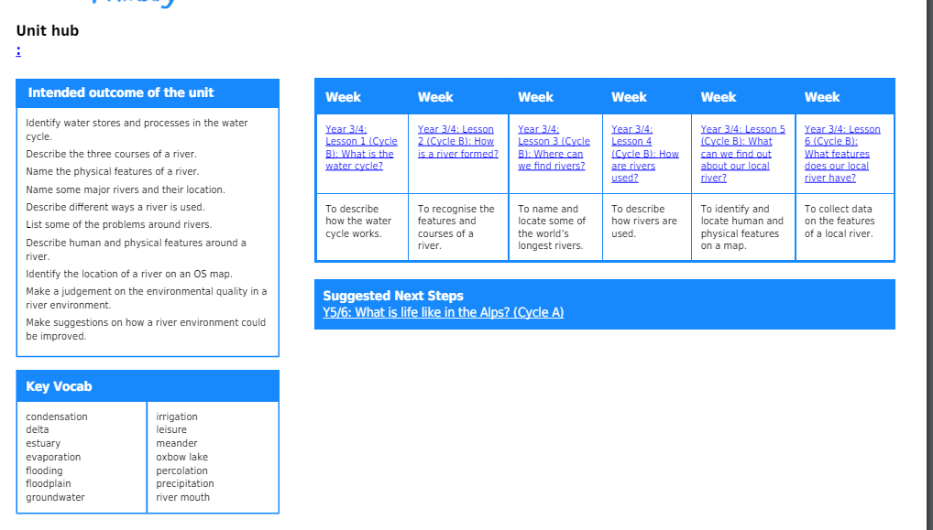

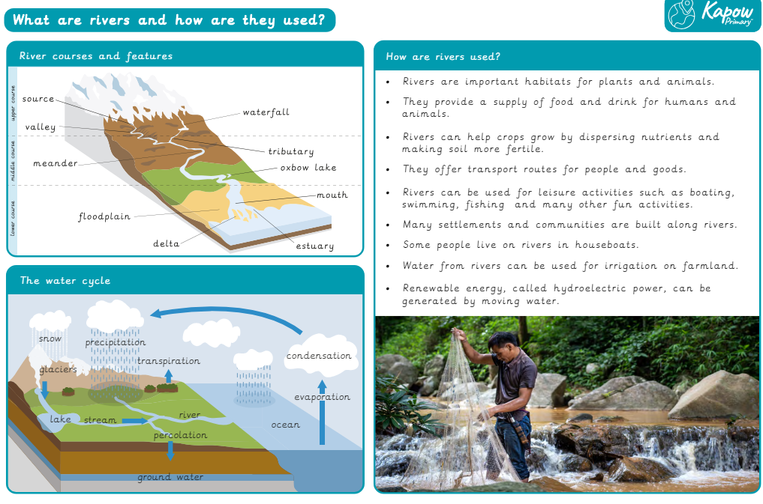
Year 6
