Big Ideas in Mastery: Representation & Structure

Messages
- The representation needs to pull out the concept being taught, and in particular the key difficulty point. It exposes the structure.
- In the end, the children need to be able to do the maths without the representation
- A stem sentence describes the representation and helps the children move to working in the abstract (“ten tenths is equivalent to one whole”) and could be seen as a representation in itself
- There will be some key representations which the children will meet time and again
- Pattern and structure are related but different: Children may have seen a pattern without understanding the structure which causes that pattern

For example:
Here are two representations for numbers within 10; the tens frame and Numicon:
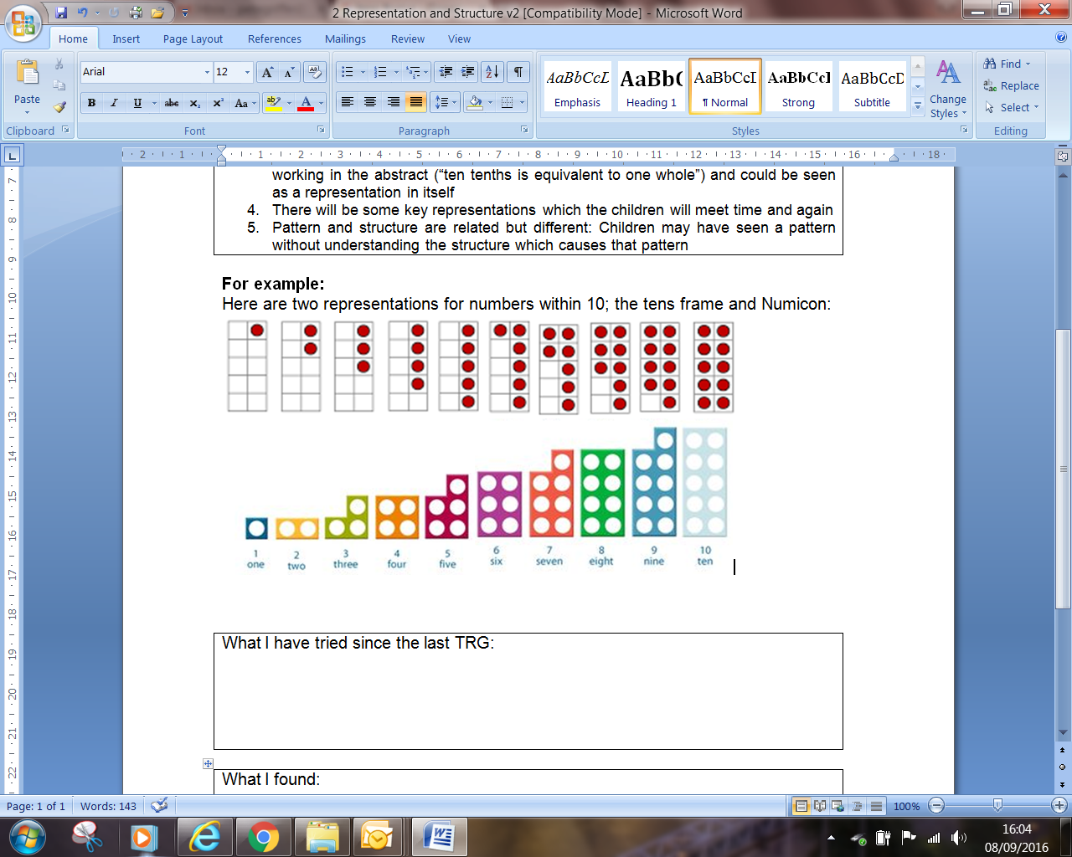
Both are very helpful concrete and pictorial representations of number but, crucially, they are representing different structures. The tens frame is accentuating and drawing attention to the ‘5 and a bit’ structure of numbers, whereas Numicon draws attention to the odd/even structure. Both images support seeing the complement to 10 (i.e. what needs to be added to make 10).
The two images of 6, for example give different (equally important) ways of thinking about the structure of 6 which in turn influence that ways the children might transform, compare and combine numbers when calculating.

What I have tried

What I found:

