Big Ideas in Mastery: Variation
Messages
- The central idea of teaching with variation is to highlight the essential features of a concept or idea through varying the non-essential features.
- When giving examples of a mathematical concept, it is useful to add variation to emphasise:
- What it is (as varied as possible);
- What it is not.
- When constructing a set of activities / questions it is important to consider what connects the examples; what mathematical structures are being highlighted?
- Variation is not the same as variety – careful attention needs to be paid to what aspects are being varied (and what is not being varied) and for what purpose.
For example:
Procedural Variation:
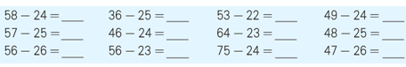
Notice how the first and second numbers (the minuend and the subtrahend) in each column of calculations have been varied. This draws attention to the relationship between the two numbers in a subtraction and encourages some reasoning to explain why the answers change in the way they do.
Working on such questions can offer learners an opportunity for ‘intelligent practice’ where they can explain what is going on and make up their own examples.

Conceptual Variation:
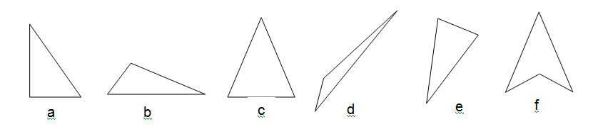
To get a sense of what a triangle is learners need to see examples of triangles which show all aspects being varied (length of sides, angles, orientation). If most triangles are shown with one side as a horizontal base and the vertex pointing upwards (as in a, b and c), this feature might be over-generalised and pupils might think that d or e are not triangles.
It is also important to give non-examples, as in f and to discuss why this is not a triangle.

What I have tried

What I found:

