Big Ideas in Mastery: Mathematical Thinking

Messages
- Mathematical thinking is central to deep and sustainable learning of mathematics.
- Taught ideas that are understood deeply are not just ‘received’ passively but worked on by the learner. They need to be thought about, reasoned with and discussed.
- Mathematical thinking involves:
  - looking for pattern in order to discern structure;
  - looking for relationships and connecting ideas;
  - reasoning logically, explaining, conjecturing and proving.

For example:
Asking “what’s the same and what’s different?” in a range of situations prompts and promotes mathematical thinking

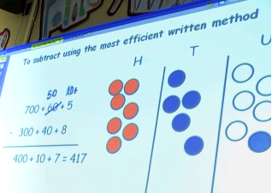
Asking pupils to explain, convince, draw diagrams to illustrate an idea or strategy, reason and conjecture as a natural part of all activity in the mathematics classroom supports deep and sustainable learning.

What I have tried

What I found:

